Data Structure and Algorithm

Laboratory Activity No. 7

Doubly Linked Lists

| *Submitted by:* | *Instructor:* |
| --- | --- |
| Elpedes, Glen Jorge A. | Engr. Maria Rizette H. Sayo |

August, 23, 2025

# Objectives

Introduction

A doubly linked list is a type of linked list data structure where each node contains three components:

Data - The actual value stored in the node

Previous pointer - A reference to the previous node in the sequence

Next pointer - A reference to the next node in the sequence.

This laboratory activity aims to implement the principles and techniques in:

* Writing algorithms using Linked list
* Writing a python program that will perform the common operations in a Doubly linked list
* A doubly linked list is particularly useful when you need frequent bidirectional traversal or easy deletion of nodes from both ends of the list.

# Methods

* Using Google Colab, type the source codes below:

class Node:

"""Node class for doubly linked list"""

def __init__(self, data):

self.data = data

self.prev = None

self.next = None

class DoublyLinkedList:

"""Doubly Linked List implementation"""

def __init__(self):

self.head = None

self.tail = None

self.size = 0

def is_empty(self):

"""Check if the list is empty"""

return self.head is None

def get_size(self):

"""Get the size of the list"""

return self.size

def display_forward(self):

"""Display the list from head to tail"""

if self.is_empty():

print("List is empty")

return

current = self.head

print("Forward: ", end="")

while current:

print(current.data, end="")

if current.next:

print(" ↔ ", end="")

current = current.next

print()

def display_backward(self):

"""Display the list from tail to head"""

if self.is_empty():

print("List is empty")

return

current = self.tail

print("Backward: ", end="")

while current:

print(current.data, end="")

if current.prev:

print(" ↔ ", end="")

current = current.prev

print()

def insert_at_beginning(self, data):

"""Insert a new node at the beginning"""

new_node = Node(data)

if self.is_empty():

self.head = self.tail = new_node

else:

new_node.next = self.head

self.head.prev = new_node

self.head = new_node

self.size += 1

print(f"Inserted {data} at beginning")

def insert_at_end(self, data):

"""Insert a new node at the end"""

new_node = Node(data)

if self.is_empty():

self.head = self.tail = new_node

else:

new_node.prev = self.tail

self.tail.next = new_node

self.tail = new_node

self.size += 1

print(f"Inserted {data} at end")

def insert_at_position(self, data, position):

"""Insert a new node at a specific position"""

if position < 0 or position > self.size:

print("Invalid position")

return

if position == 0:

self.insert_at_beginning(data)

return

elif position == self.size:

self.insert_at_end(data)

return

new_node = Node(data)

current = self.head

# Traverse to the position

for _ in range(position - 1):

current = current.next

# Insert the new node

new_node.next = current.next

new_node.prev = current

current.next.prev = new_node

current.next = new_node

self.size += 1

print(f"Inserted {data} at position {position}")

def delete_from_beginning(self):

"""Delete the first node"""

if self.is_empty():

print("List is empty")

return None

deleted_data = self.head.data

if self.head == self.tail: # Only one node

self.head = self.tail = None

else:

self.head = self.head.next

self.head.prev = None

self.size -= 1

print(f"Deleted {deleted_data} from beginning")

return deleted_data

def delete_from_end(self):

"""Delete the last node"""

if self.is_empty():

print("List is empty")

return None

deleted_data = self.tail.data

if self.head == self.tail: # Only one node

self.head = self.tail = None

else:

self.tail = self.tail.prev

self.tail.next = None

self.size -= 1

print(f"Deleted {deleted_data} from end")

return deleted_data

def delete_from_position(self, position):

"""Delete a node from a specific position"""

if self.is_empty():

print("List is empty")

return None

if position < 0 or position >= self.size:

print("Invalid position")

return None

if position == 0:

return self.delete_from_beginning()

elif position == self.size - 1:

return self.delete_from_end()

current = self.head

# Traverse to the position

for _ in range(position):

current = current.next

# Delete the node

deleted_data = current.data

current.prev.next = current.next

current.next.prev = current.prev

self.size -= 1

print(f"Deleted {deleted_data} from position {position}")

return deleted_data

def search(self, data):

"""Search for a node with given data"""

if self.is_empty():

return -1

current = self.head

position = 0

while current:

if current.data == data:

return position

current = current.next

position += 1

return -1

def reverse(self):

"""Reverse the doubly linked list"""

if self.is_empty() or self.head == self.tail:

return

current = self.head

self.tail = self.head

while current:

# Swap next and prev pointers

temp = current.prev

current.prev = current.next

current.next = temp

# Move to the next node (which is now in prev due to swap)

current = current.prev

# Update head to the last node we processed

if temp:

self.head = temp.prev

print("List reversed successfully")

def clear(self):

"""Clear the entire list"""

self.head = self.tail = None

self.size = 0

print("List cleared")

# Demonstration and testing

def demo_doubly_linked_list():

"""Demonstrate the doubly linked list operations"""

print("=" * 50)

print("DOUBLY LINKED LIST DEMONSTRATION")

print("=" * 50)

dll = DoublyLinkedList()

# Insert operations

dll.insert_at_beginning(10)

dll.insert_at_end(20)

dll.insert_at_end(30)

dll.insert_at_beginning(5)

dll.insert_at_position(15, 2)

# Display

dll.display_forward()

dll.display_backward()

print(f"Size: {dll.get_size()}")

print()

# Search operation

search_value = 20

position = dll.search(search_value)

if position != -1:

print(f"Found {search_value} at position {position}")

else:

print(f"{search_value} not found in the list")

print()

# Delete operations

dll.delete_from_beginning()

dll.delete_from_end()

dll.delete_from_position(1)

# Display after deletions

dll.display_forward()

print(f"Size: {dll.get_size()}")

print()

# Insert more elements

dll.insert_at_end(40)

dll.insert_at_end(50)

dll.insert_at_end(60)

# Display before reverse

print("Before reverse:")

dll.display_forward()

# Reverse the list

dll.reverse()

# Display after reverse

print("After reverse:")

dll.display_forward()

dll.display_backward()

print()

# Clear the list

dll.clear()

dll.display_forward()

# Interactive menu for user to test

def interactive_menu():

"""Interactive menu for testing the doubly linked list"""

dll = DoublyLinkedList()

while True:

print("\n" + "=" * 40)

print("DOUBLY LINKED LIST MENU")

print("=" * 40)

print("1. Insert at beginning")

print("2. Insert at end")

print("3. Insert at position")

print("4. Delete from beginning")

print("5. Delete from end")

print("6. Delete from position")

print("7. Search element")

print("8. Display forward")

print("9. Display backward")

print("10. Reverse list")

print("11. Get size")

print("12. Clear list")

print("13. Exit")

print("=" * 40)

choice = input("Enter your choice (1-13): ")

if choice == '1':

data = int(input("Enter data to insert: "))

dll.insert_at_beginning(data)

elif choice == '2':

data = int(input("Enter data to insert: "))

dll.insert_at_end(data)

elif choice == '3':

data = int(input("Enter data to insert: "))

position = int(input("Enter position: "))

dll.insert_at_position(data, position)

elif choice == '4':

dll.delete_from_beginning()

elif choice == '5':

dll.delete_from_end()

elif choice == '6':

position = int(input("Enter position to delete: "))

dll.delete_from_position(position)

elif choice == '7':

data = int(input("Enter data to search: "))

pos = dll.search(data)

if pos != -1:

print(f"Element found at position {pos}")

else:

print("Element not found")

elif choice == '8':

dll.display_forward()

elif choice == '9':

dll.display_backward()

elif choice == '10':

dll.reverse()

elif choice == '11':

print(f"Size: {dll.get_size()}")

elif choice == '12':

dll.clear()

elif choice == '13':

print("Exiting...")

break

else:

print("Invalid choice! Please try again.")

if __name__ == "__main__":

# Run the demonstration

demo_doubly_linked_list()

# Uncomment the line below to run interactive menu

# interactive_menu()

* Save your source codes to GitHub

Answer the following questions:

* + 1. What are the three main components of a Node in the doubly linked list implementation, and what does the __init__ method of the DoublyLinkedList class initialize?
    2. The insert_at_beginning method successfully adds a new node to the start of the list. However, if we were to reverse the order of the two lines of code inside the else block, what specific issue would this introduce? Explain the sequence of operations that would lead to this problem:

def insert_at_beginning(self, data):

new_node = Node(data)

if self.is_empty():

self.head = self.tail = new_node

else:

new_node.next = self.head

self.head.prev = new_node

self.head = new_node

self.size += 1

* + 1. How does the reverse method work? Trace through the reversal process step by step for a list containing [A, B, C], showing the pointer changes at each iteration

def reverse(self):

if self.is_empty() or self.head == self.tail:

return

current = self.head

self.tail = self.head

while current:

temp = current.prev

current.prev = current.next

current.next = temp

current = current.prev

if temp:

self.head = temp.prev

# Results

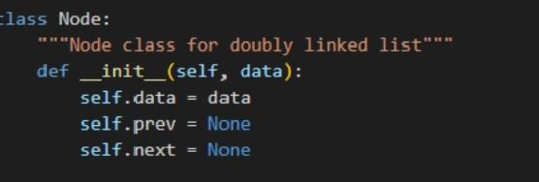

Figure 1 Class Node Initialize

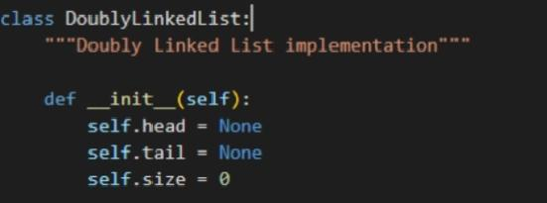

Figure 2 DoubleLinkedList class initialize

For question 1, the three primary elements of a node in a doubly linked list (as illustrated in Figure 1) are  self.data ,  self.prev , and  self.next . The  DoubleLinkedList  class initializes  self.head  and  self.tails .

For Question 2

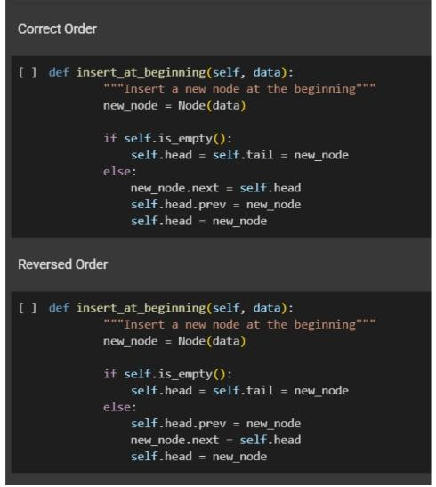

Figure 3 No.2 Problem

**Problem Explanation:**

If you set  self.head.prev = new_node  before assigning  new_node.next = self.head , the

new node isn’t fully connected. At this stage,  new_node.next  is still  None , creating an inconsistent link.

- The original head’s  prev  will now point to the new node.

- However, the new node hasn’t been linked back to the original head (its  next  remains

 None ).

- This results in a broken forward connection in the list.

Error Sequence:

1. The original head’s  prev  points to the new node.

2. The new node lacks a link to the original head (its  next  is  None ).

3. Traversing the list from the head fails, as the forward path to the original head is lost.

For Question 3

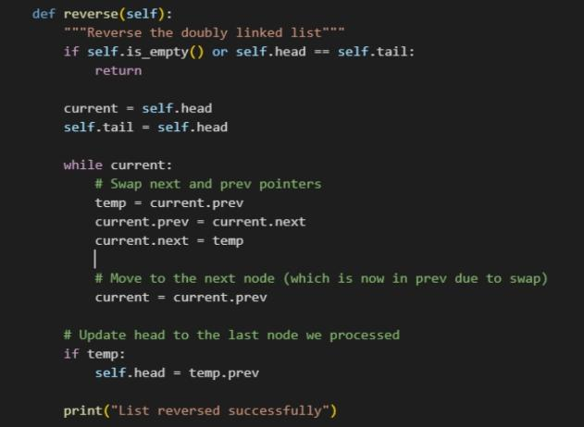

Figure 4 No. 3 problem

Initial List: A ⇔ B ⇔ C

 head = A ,  tail = C

Step - by - Step Reversal Process:

1. Start with node A:

- Swap its  prev  and  next  pointers.

- Now, A’s  prev  points to B, and A’s  next  is None.

- Move to node B.

2. At node B:

- Swap its  prev  and  next  pointers.

- Now, B’s  prev  points to C, and B’s  next  points to A.

- Move to node C.

3. At node C:

- Swap its  prev  and  next  pointers.

- Now, C’s  prev  is None, and C’s  next  points to B.

- Move to the next node (which is None) → stop.

4. Update the head:

- Set the head to the last node processed (C).

- Final List: C ⇔ B ⇔ A

-  head = C ,  tail = A

# Conclusion

This laboratory exercise deepened my understanding of the structure and complexities of

a doubly linked list. By exploring this key topic, I gained a more solid grasp of fundamental Data Structures and Algorithms concepts.

**References**

[1] T. Belsare, “Mastering Data Structures: A comprehensive guide to doubly linked lists in Python,” Apr. 10, 2024. <https://www.linkedin.com/pulse/mastering-data-structures-comprehensive-guide-doubly-linked-belsare-7icuc?trk=public_post&need_sec_link=1&sec_link_scene=im&theme=light>

[2] www.naukri.com, “Code 360 by Coding Ninjas,” 2024 Naukri.com. <https://sg-link.byteoversea.com/?aid=489823&lang=en&scene=im&jumper_version=1&target=https%3A%2F%2Fwww.codingninjas.com%2Fstudio%2Flibrary%2Fadvantages-disadvantages-and-uses-of-a-doubly-linked-list%3Fneed_sec_link%3D1%26sec_link_scene%3Dim&theme=light>